**How to Update the NGO data for the DaanMatch App**

**\*\*NOTE** It is assumed that the Geocoding of Addresses or Latitude and Longitude has already been done before starting this process. The geocoding can be done in ArcGIS online but it costs credits each time it is done, and the match rate is very low if you are trying to geocode by address. My suggestion for geocoding is to get the Lat\Long info for each new location, add that to a .CSV file, then append that file into the existing NGO dataset, which is what will be explained below.**

1. Go to ArcGIS Online at [THIS LINK](https://www.arcgis.com/sharing/oauth2/authorize?client_id=arcgisonline&response_type=code&state=%7B%22portalUrl%22%3A%22https%3A%2F%2Fwww.arcgis.com%22%2C%22uid%22%3A%22uc_vRCp9OYNfrHc6y9txXdi9bzYITtljWNdI7hMoMqo%22%2C%22useLandingPage%22%3Atrue%2C%22clientId%22%3A%22arcgisonline%22%7D&expiration=20160&locale=en-us&redirect_uri=https%3A%2F%2Fwww.arcgis.com%2Fhome%2Faccountswitcher-callback.html&force_login=true&redirectToUserOrgUrl=true&code_challenge=vFiU_C3GvTbxsWmZDbYj6xnHxL0oIErCCsxf_JeJX0w&code_challenge_method=S256&display=default&hideCancel=true&showSignupOption=true&canHandleCrossOrgSignIn=true&signuptype=esri&allow_verification=true) and sign in with your ArcGIS online credentials.
2. Go to the folder named **‘Instant App Data’**, this is where all the pieces associated with the Instant App are located.
3. In the folder you will see the layers shown in the picture below:

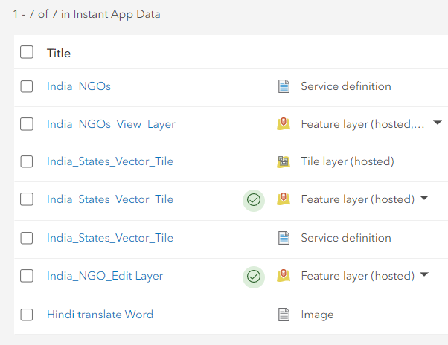

1. All the work will be performed on the layer named ***“India_NGO_Edit_Layer”*** as an FYI the “View Layer” is a copy of the “Edit Layer” and the “View Layer” is what is used in the Instant app. So the edits happen to the **“Edit Layer**” which in turn updates the “View Layer”, which in turn updates the Instant App.
2. **A note about the “.CSV” file you create:**: make sure that the column names in the file are the same as they are in the ***“India_NGO_Edit_Layer”*** that way all the data “knows” where it belongs. It is especially important to have a number in the field named ***“Field1”,*** this is a numeric ID field.
3. When you have your “.CSV” file with your new locations and their respective Latitude and Longitude locations all set, click on the layer titled ***“India_NGO_Edit_Layer”,*** you will then see the following options:

:

1. Choose the ***“Update Data”*** option then “***Append Data to layer”*** 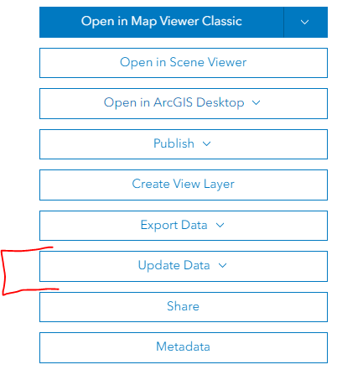
2. You are then asked to provide the file that contains your updated Latitude and Longitude information as shown in the picture below:

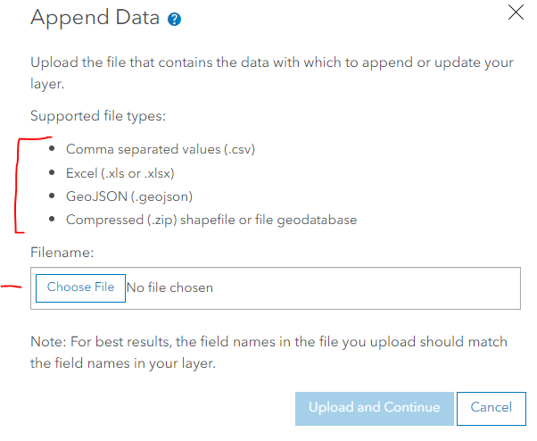

1. Choose your file then click **“Upload and Continue”**.
2. The next dialog box asks if you want to “update existing” features, leave the box unchecked as shown here:

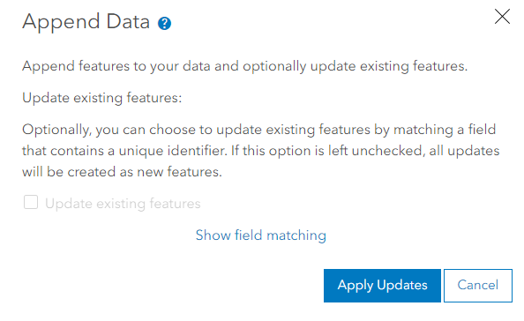

1. Click “**Apply Updates**” to continue on.
2. You should see a green box in the upper right hand corner of the screen telling you the **“Updates were successfully Applied”** afterwards.
3. To check that go to the **“Data”** tab on the layer title ribbon as shown here:

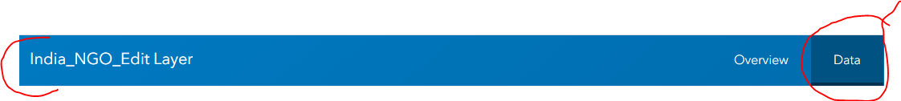

1. Scroll to the end of that list and will see the new features on that list. A true test of the new data being there is to go to the Instant App and search for the name of one of the newly added NGO’s.
2. You just updated the India NGO data layer, and in turn the Instant App. You will follow these instructions the next time it needs updating.